What is SAST?
SAST = Static Application Security Testing
In simple words:
SAST is a security technique that scans the application's source code to find security vulnerabilities without running the application.

Think about a code review
Suppose a developer writes:
search = request.args.get("search")
query = f"SELECT * FROM users WHERE name = '{search}'"
A developer may look at this and say:
"Looks like normal Python code."
But a security engineer might say:
🚨 "Wait! User input is going directly into an SQL query."
This can lead to SQL Injection.
Now imagine your application has:
100 files
10,000 lines of code
100 developers
A human can't reliably inspect every line for security problems.
That's where SAST comes in.
Developer writes code
↓
SAST
↓
Analyzes source code
↓
Finds security weaknesses
↓
🚨 Alert
#################
Why is it called STATIC?
This is a very important word.
Static = the application is NOT running.
SAST looks at:
Source Code
↓
Analyze
↓
Security Findings
It doesn't need:
Browser
Server
Database
Live Application
to perform its basic analysis.
That's why we call it Static Application Security Testing.

What can SAST find?
Depending on the tool, SAST can identify things such as:
- SQL Injection
- Command Injection
- Hardcoded credentials
- Cross-Site Scripting (XSS)
- Unsafe API usage
- Path traversal
- Insecure data flows
- Other coding/security weaknesses
Where does SAST fit in DevSecOps?
Developer
↓
Commit
↓
SAST
↓
Security Check
↓
Build
↓
Test
↓
Deploy
DEMO:

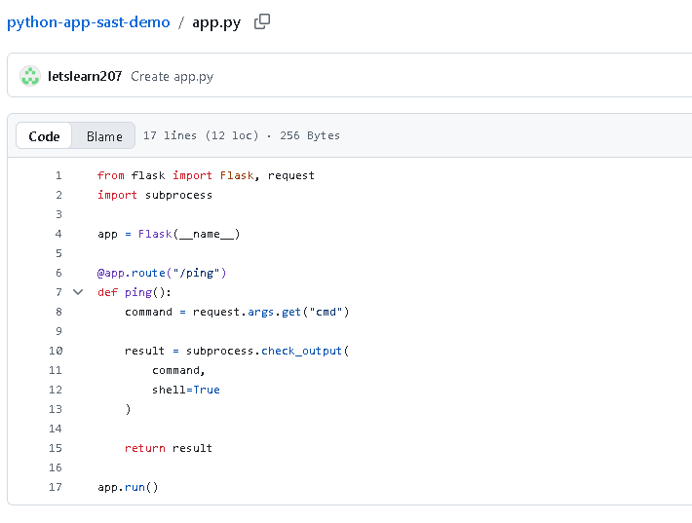
Push the code to github

Now go to settings:
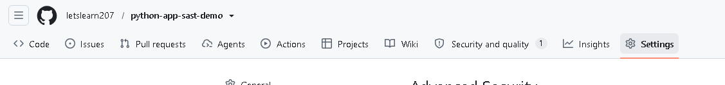
Advanced security
Click on …
and enable codeql
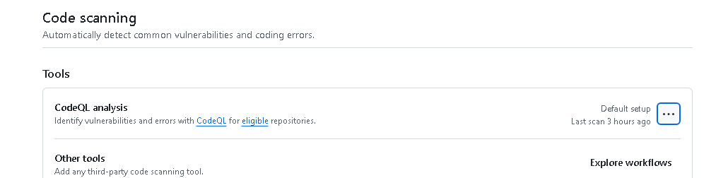
.github/workflows/codeql.yml
name: SAST - CodeQL
on:
push:
branches: [ master ]
pull_request:
branches: [ master ]
jobs:
codeql:
name: CodeQL SAST Scan
runs-on: ubuntu-latest
permissions:
contents: read
security-events: write
steps:
- name: Checkout Code
uses: actions/checkout@v4
- name: Initialize CodeQL
uses: github/codeql-action/init@v4
with:
languages: python
- name: Analyze Code
uses: github/codeql-action/analyze@v4

## See the analysis



